Test Case: tc007_SPX_Dev5_Validacion_Boton_Edit_Administrador_Menu
Step 1 - Enter username and password and click to button Enter : Credentials Entered
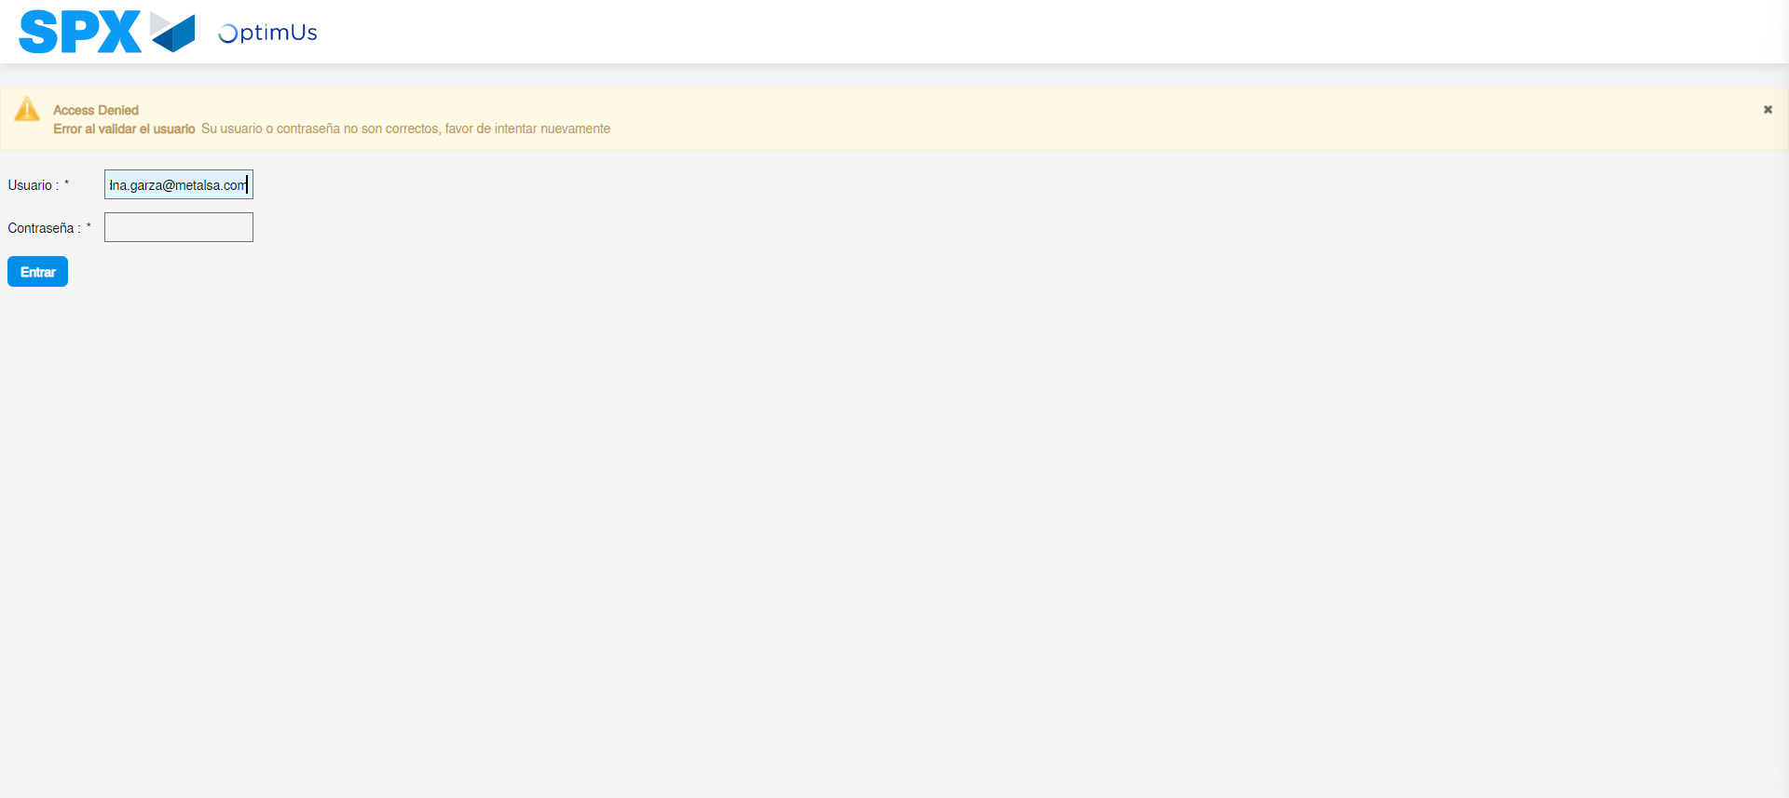Image file-name: QC_Testing-tc007_SPX_Dev5_Validacion_Boton_Edit_Administrador_Menu-may. 15 2024, 01 02 48 p. m.

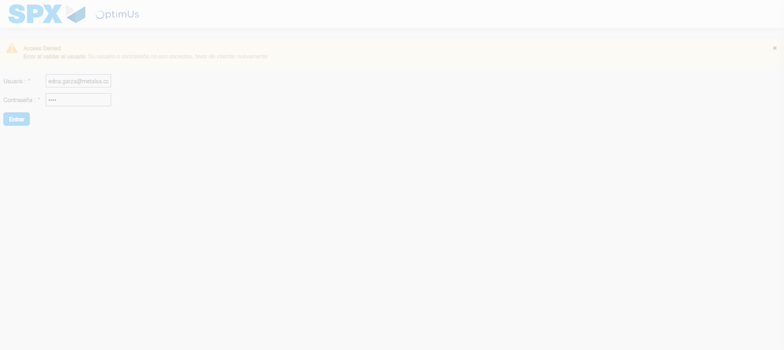Image file-name: QC_Testing-tc007_SPX_Dev5_Validacion_Boton_Edit_Administrador_Menu-may. 15 2024, 01 02 49 p. m.

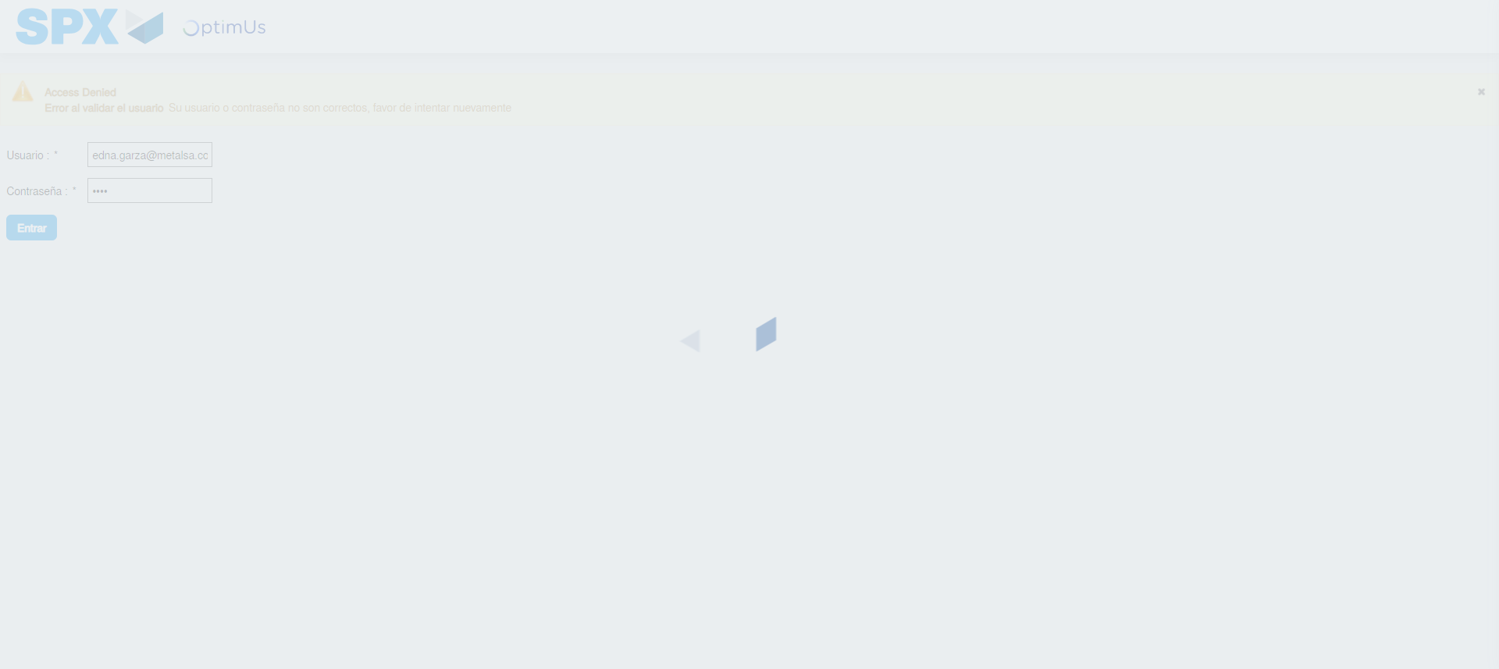Image file-name: QC_Testing-tc007_SPX_Dev5_Validacion_Boton_Edit_Administrador_Menu-may. 15 2024, 01 02 50 p. m.

Step 2 - Select to UEN and Access to Administrador Roles Menu: UEN Correctly selected and Correct access
Image file-name: QC_Testing-tc007_SPX_Dev5_Validacion_Boton_Edit_Administrador_Menu-may. 15 2024, 01 02 54 p. m.

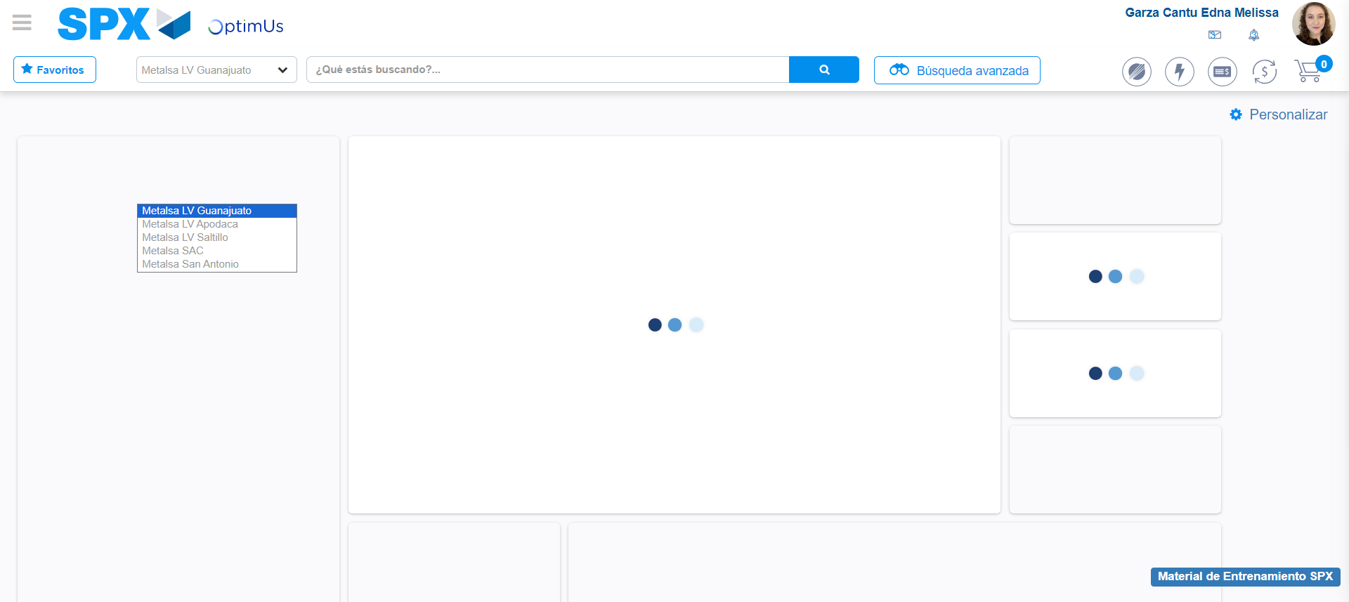Image file-name: QC_Testing-tc007_SPX_Dev5_Validacion_Boton_Edit_Administrador_Menu-may. 15 2024, 01 02 55 p. m.

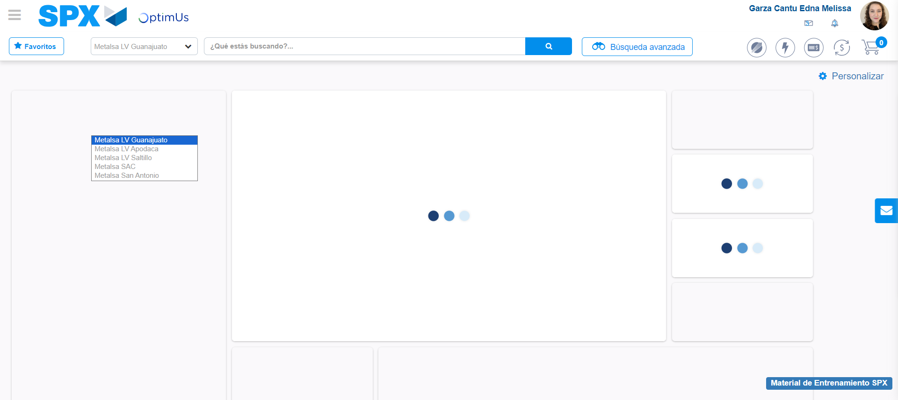Image file-name: QC_Testing-tc007_SPX_Dev5_Validacion_Boton_Edit_Administrador_Menu-may. 15 2024, 01 02 56 p. m.

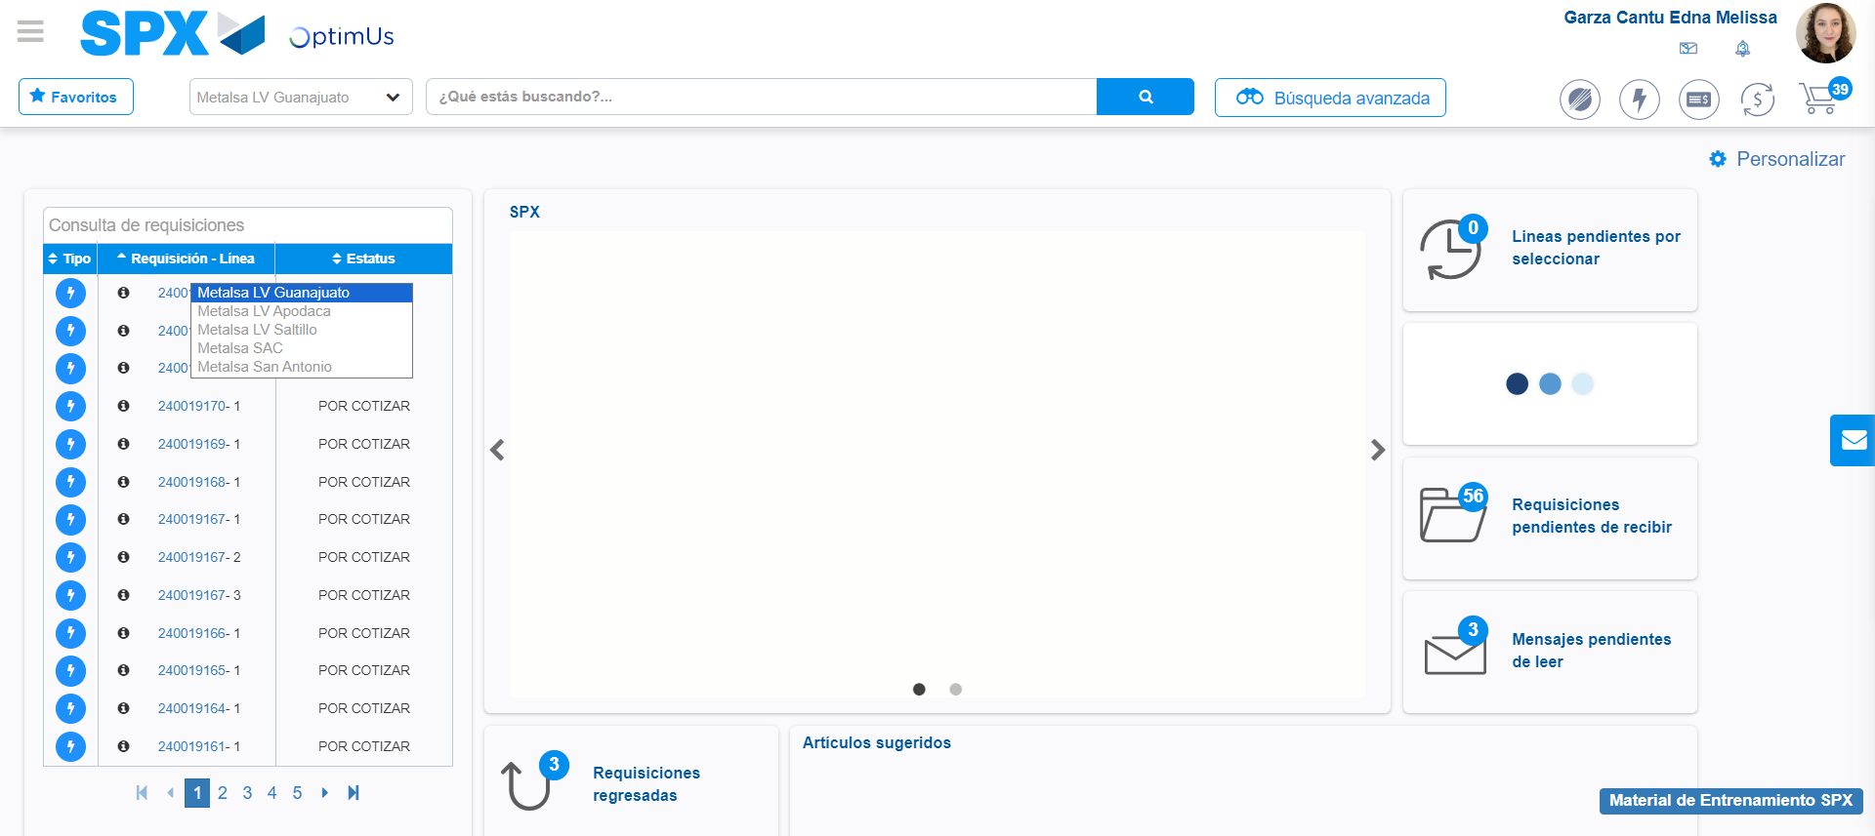Image file-name: QC_Testing-tc007_SPX_Dev5_Validacion_Boton_Edit_Administrador_Menu-may. 15 2024, 01 02 57 p. m.

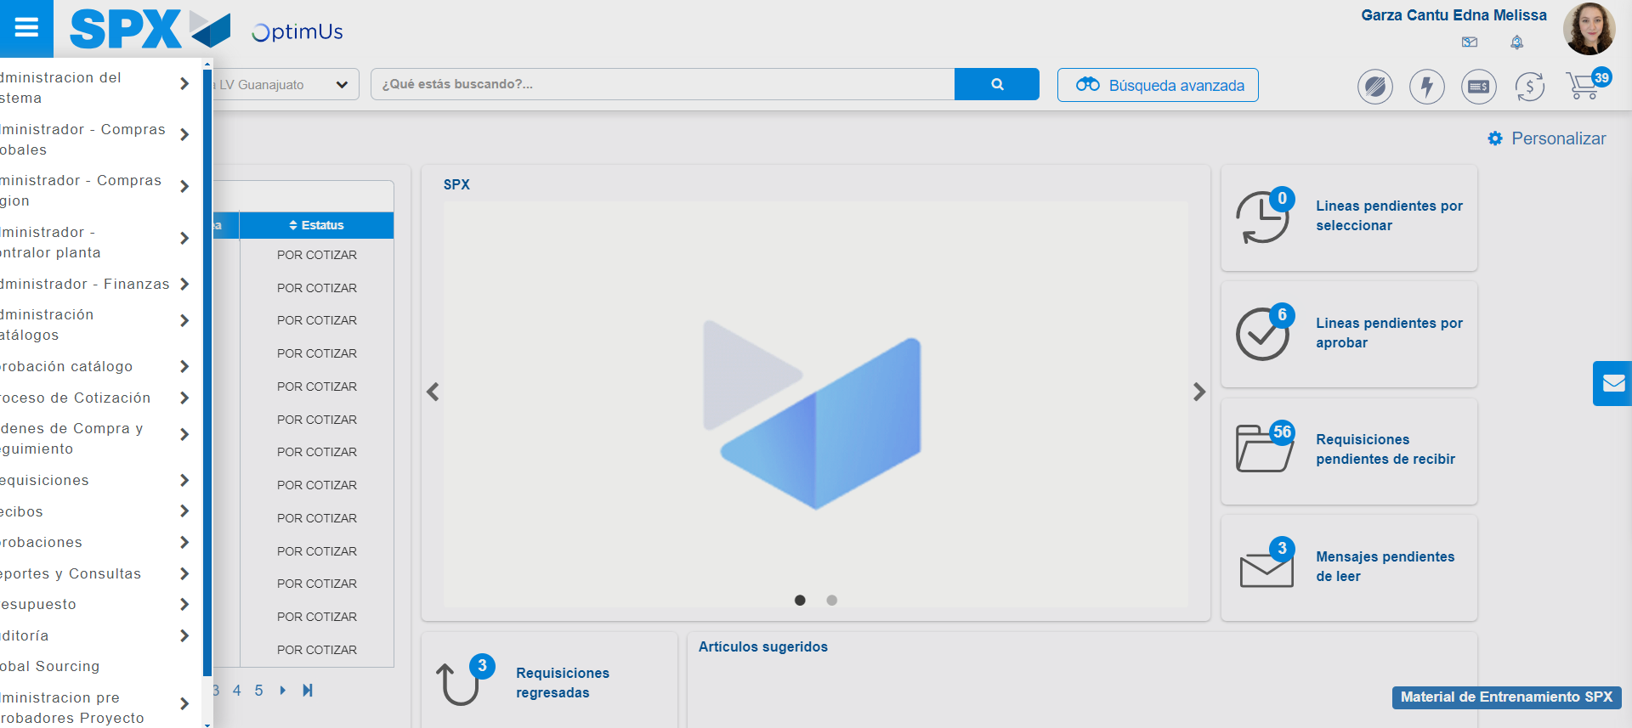Image file-name: QC_Testing-tc007_SPX_Dev5_Validacion_Boton_Edit_Administrador_Menu-may. 15 2024, 01 02 58 p. m.

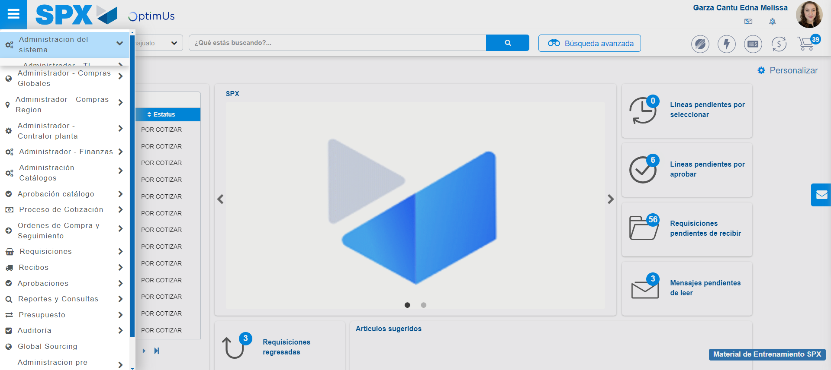Image file-name: QC_Testing-tc007_SPX_Dev5_Validacion_Boton_Edit_Administrador_Menu-may. 15 2024, 01 02 59 p. m.

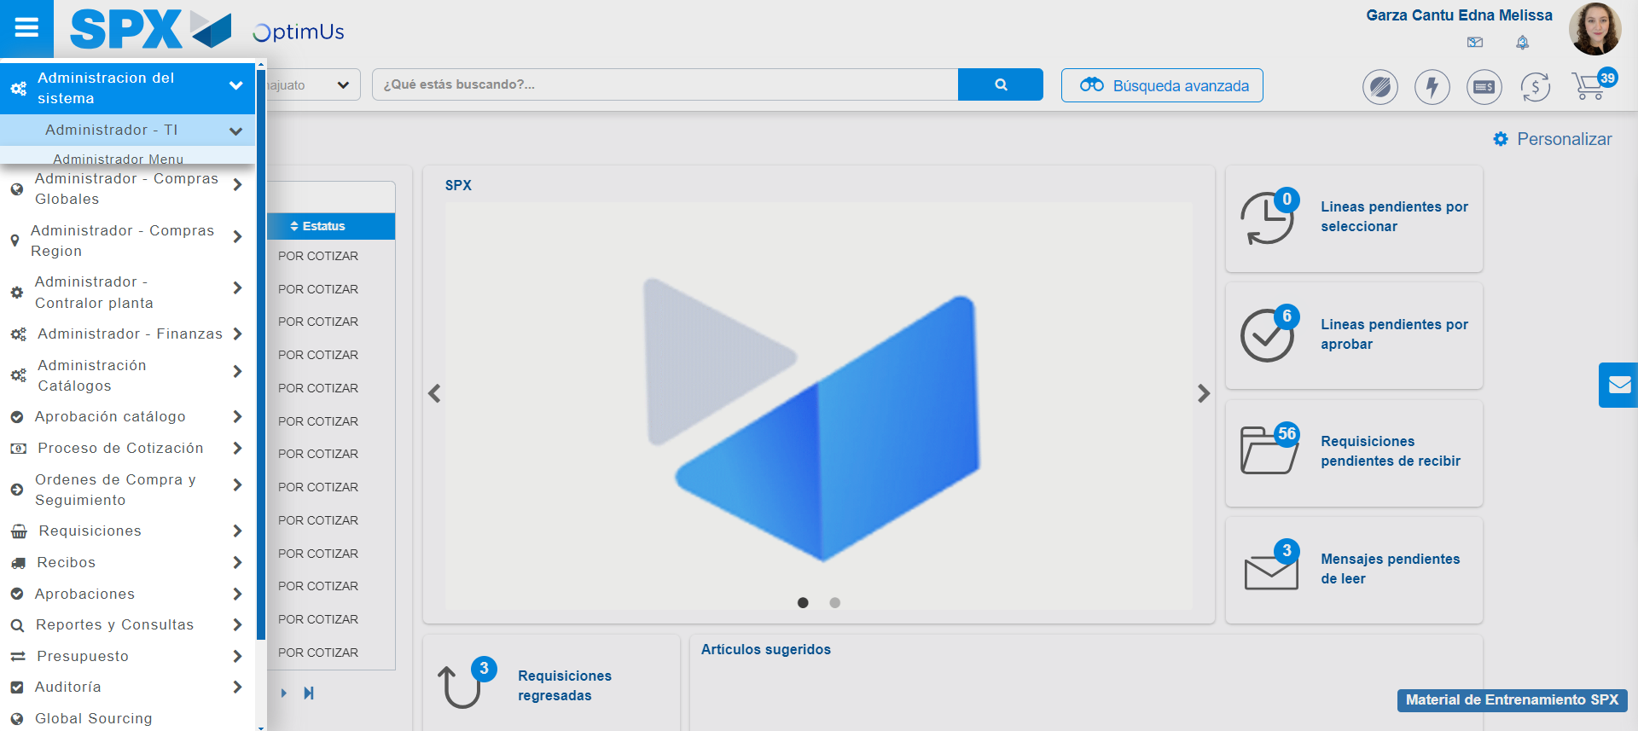Image file-name: QC_Testing-tc007_SPX_Dev5_Validacion_Boton_Edit_Administrador_Menu-may. 15 2024, 01 03 00 p. m.

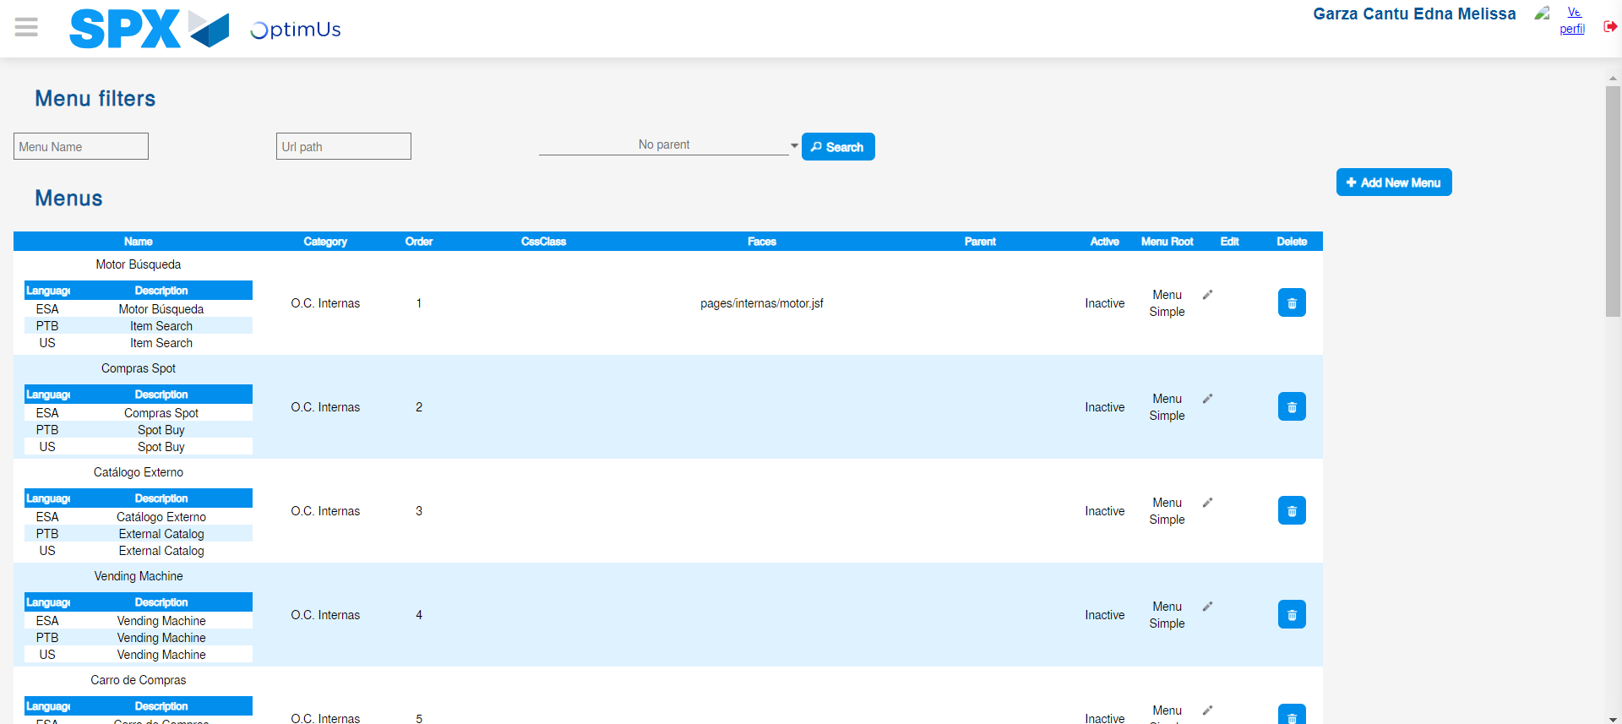Image file-name: QC_Testing-tc007_SPX_Dev5_Validacion_Boton_Edit_Administrador_Menu-may. 15 2024, 01 03 03 p. m.

Step 3 - Add new menu and edit fields: New menu successfully registered
Image file-name: QC_Testing-tc007_SPX_Dev5_Validacion_Boton_Edit_Administrador_Menu-may. 15 2024, 01 03 04 p. m.

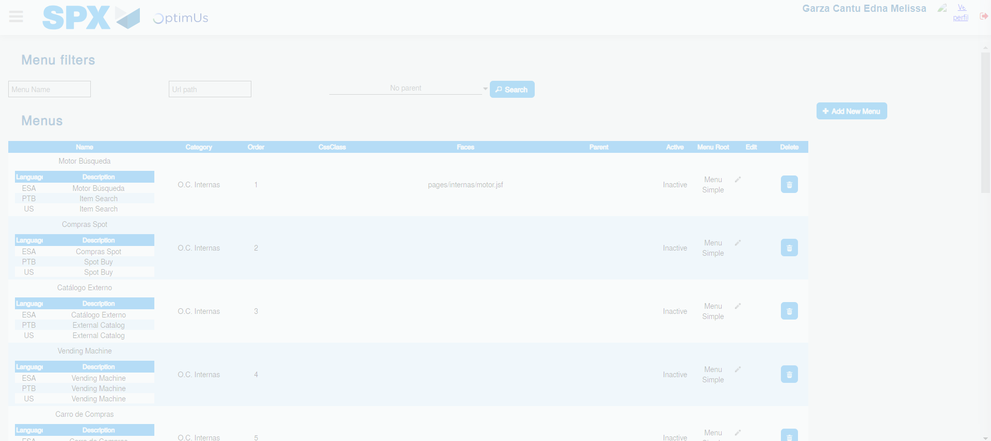Image file-name: QC_Testing-tc007_SPX_Dev5_Validacion_Boton_Edit_Administrador_Menu-may. 15 2024, 01 03 05 p. m.

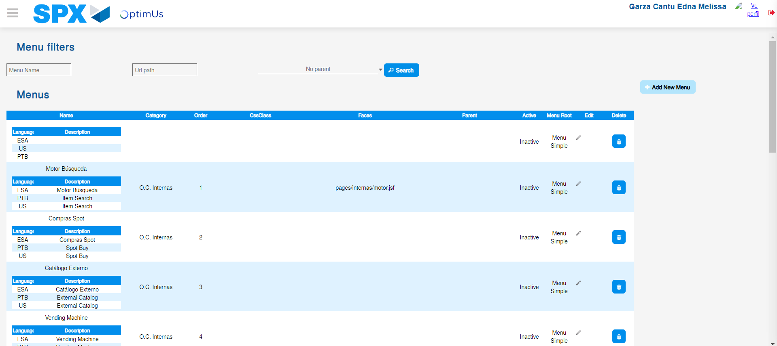Image file-name: QC_Testing-tc007_SPX_Dev5_Validacion_Boton_Edit_Administrador_Menu-may. 15 2024, 01 03 08 p. m.

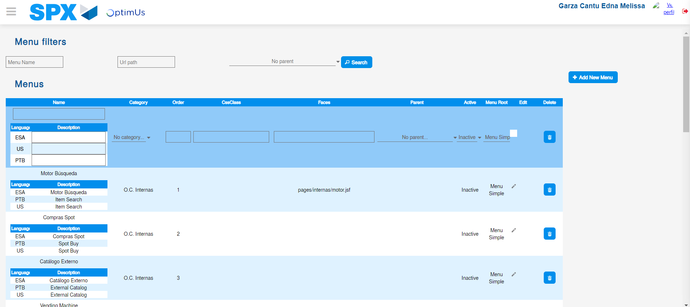Image file-name: QC_Testing-tc007_SPX_Dev5_Validacion_Boton_Edit_Administrador_Menu-may. 15 2024, 01 03 09 p. m.

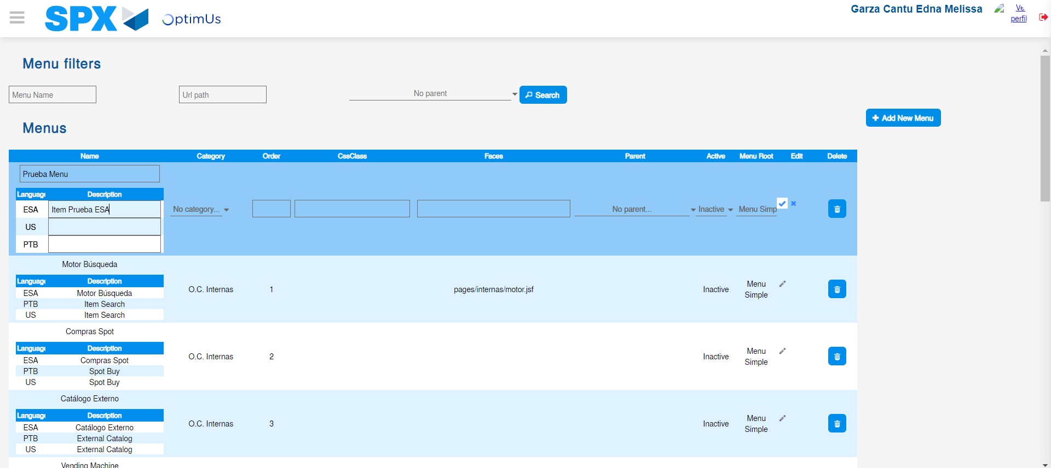Image file-name: QC_Testing-tc007_SPX_Dev5_Validacion_Boton_Edit_Administrador_Menu-may. 15 2024, 01 03 10 p. m.

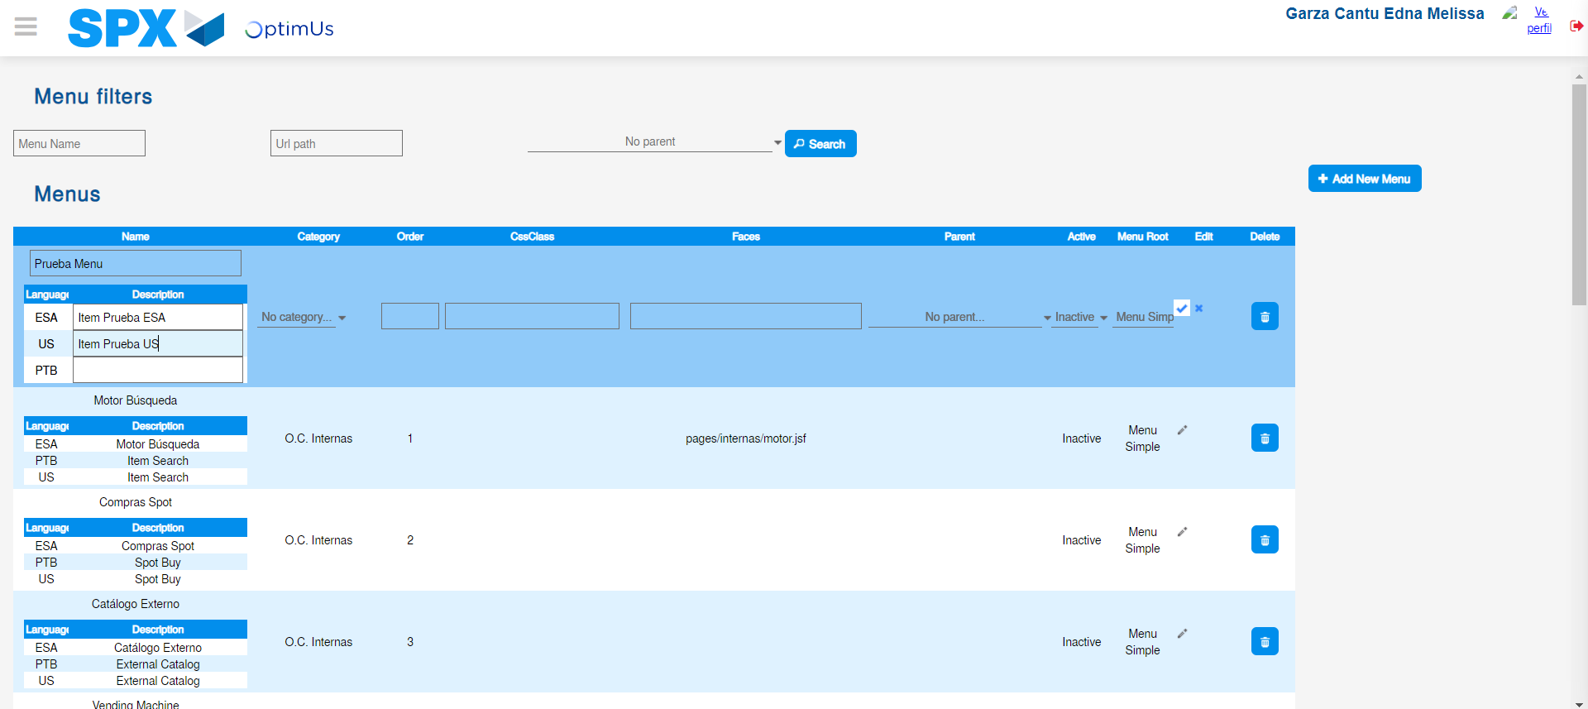Image file-name: QC_Testing-tc007_SPX_Dev5_Validacion_Boton_Edit_Administrador_Menu-may. 15 2024, 01 03 11 p. m.

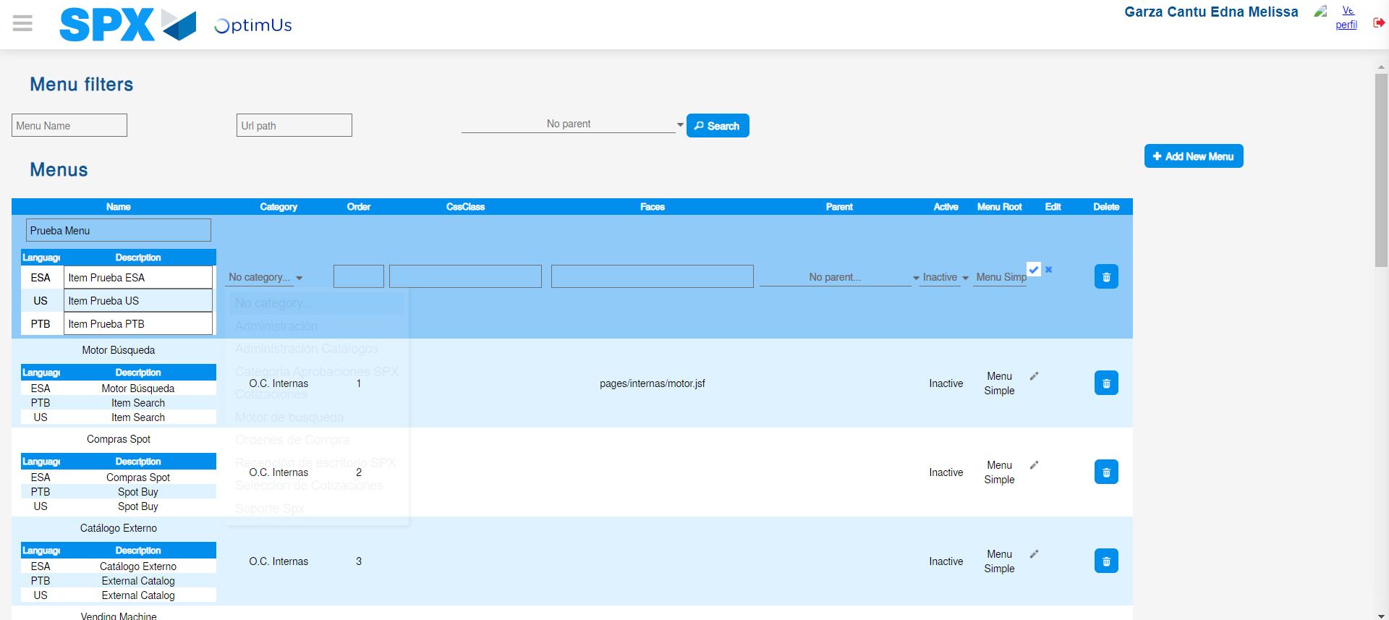Image file-name: QC_Testing-tc007_SPX_Dev5_Validacion_Boton_Edit_Administrador_Menu-may. 15 2024, 01 03 12 p. m.

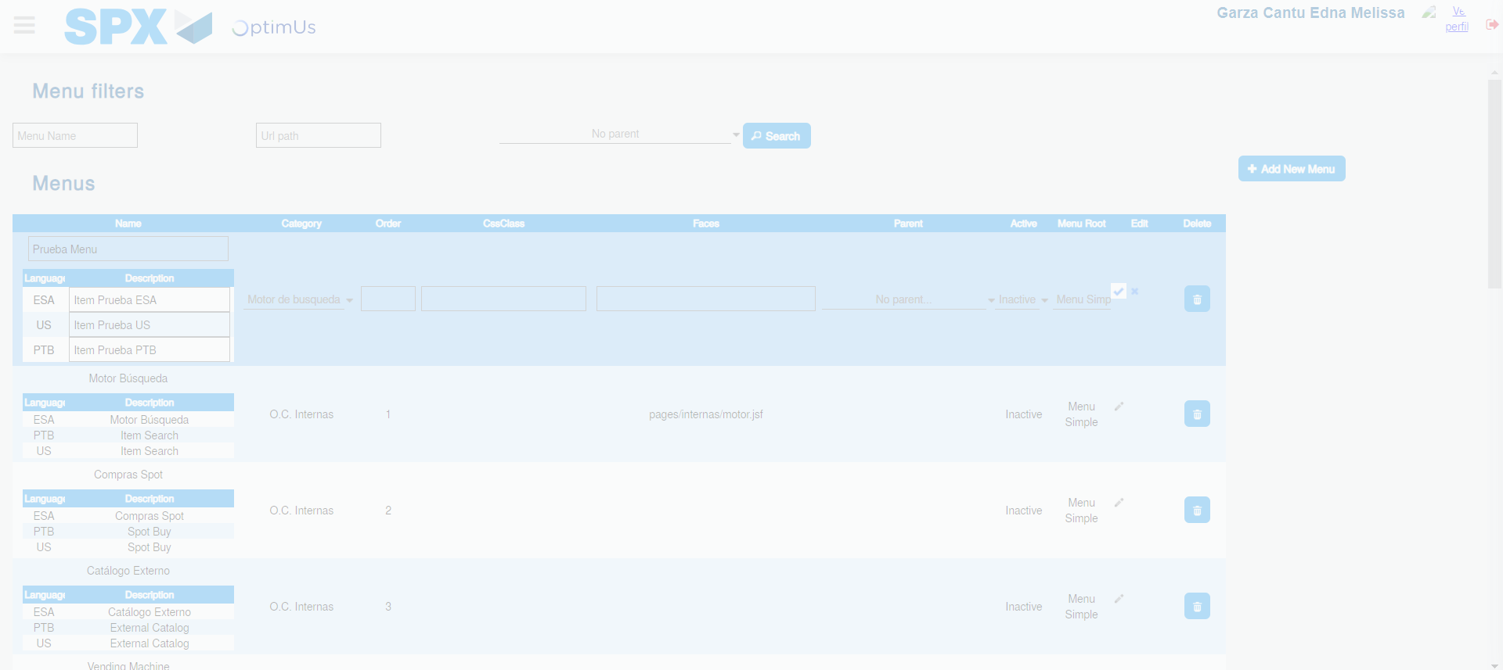Image file-name: QC_Testing-tc007_SPX_Dev5_Validacion_Boton_Edit_Administrador_Menu-may. 15 2024, 01 03 13 p. m.

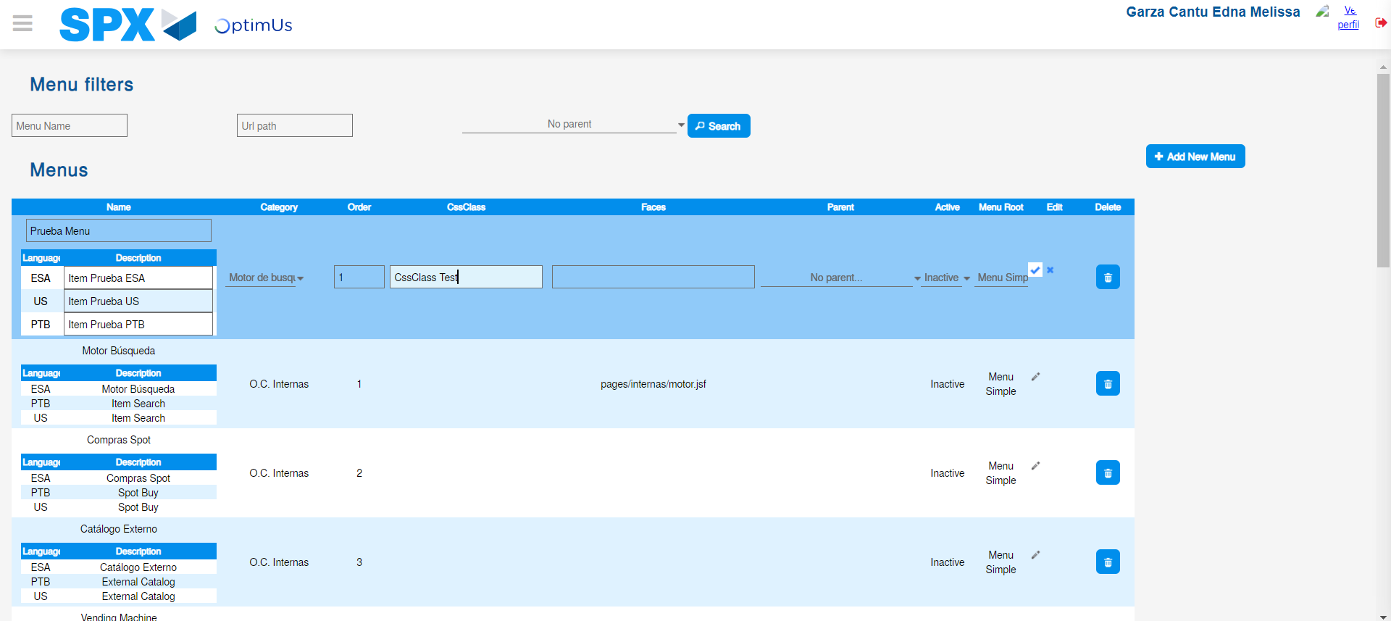Image file-name: QC_Testing-tc007_SPX_Dev5_Validacion_Boton_Edit_Administrador_Menu-may. 15 2024, 01 03 14 p. m.

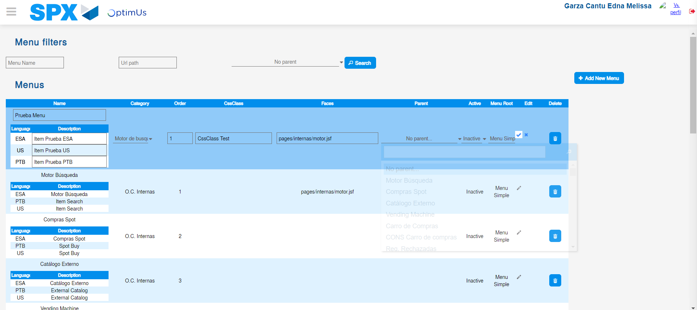Image file-name: QC_Testing-tc007_SPX_Dev5_Validacion_Boton_Edit_Administrador_Menu-may. 15 2024, 01 03 15 p. m.

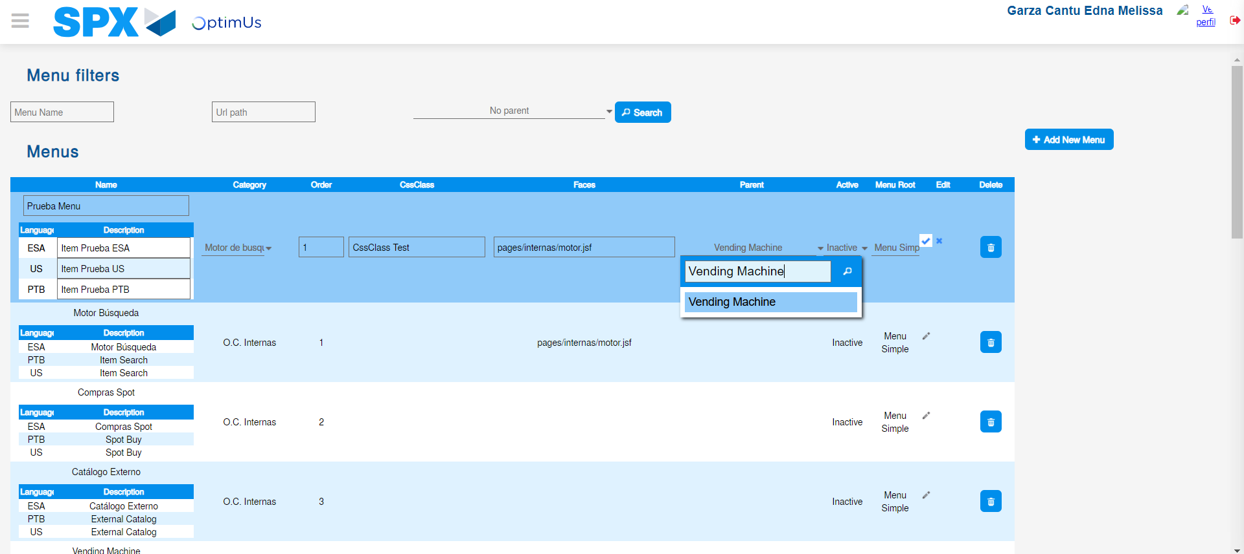Image file-name: QC_Testing-tc007_SPX_Dev5_Validacion_Boton_Edit_Administrador_Menu-may. 15 2024, 01 03 16 p. m.

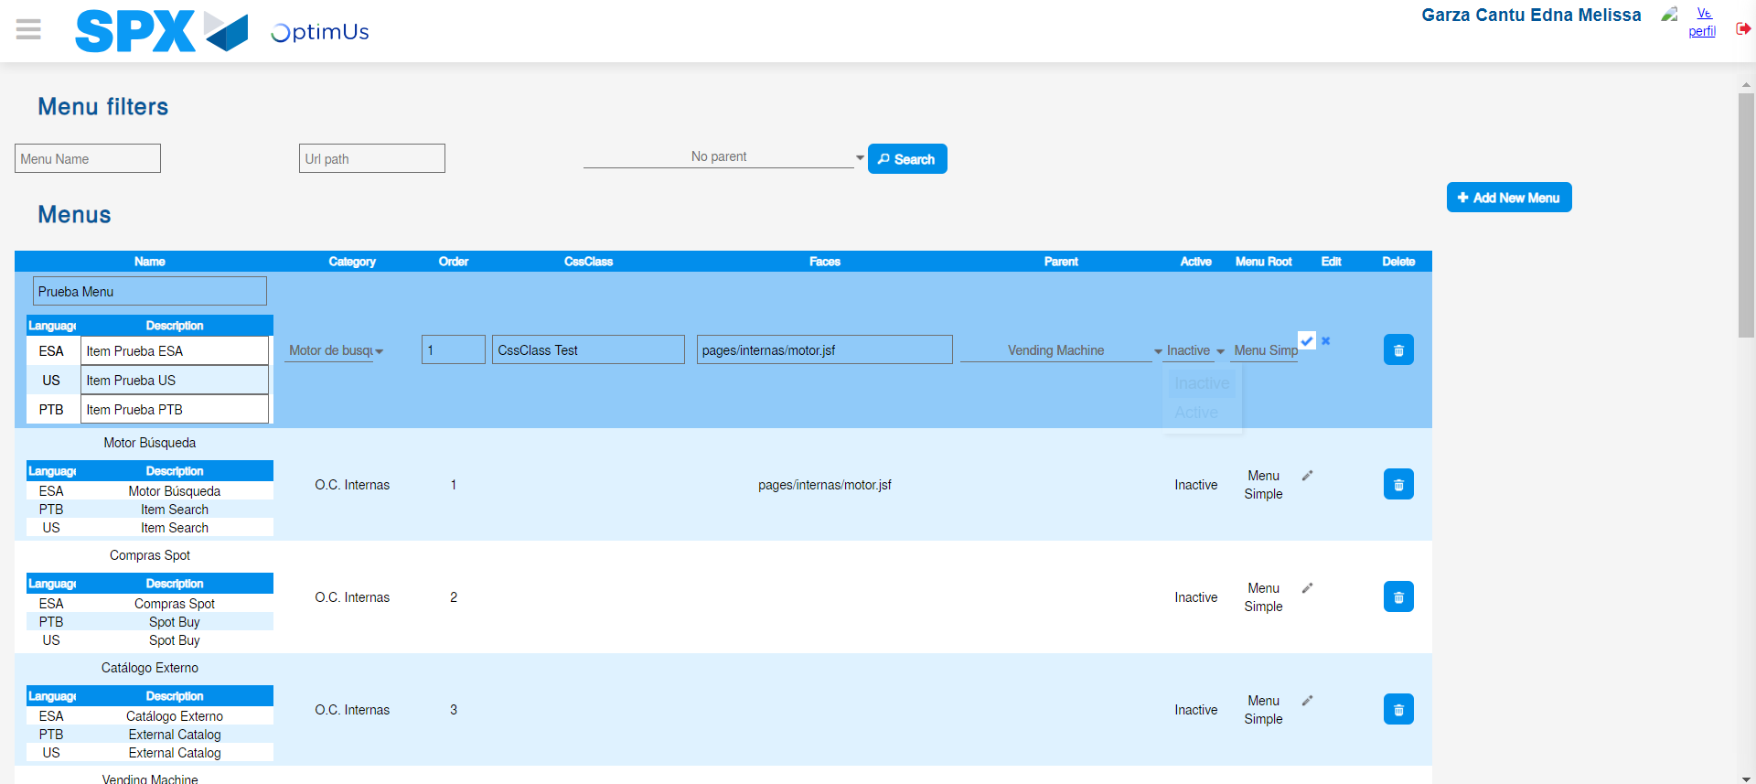Image file-name: QC_Testing-tc007_SPX_Dev5_Validacion_Boton_Edit_Administrador_Menu-may. 15 2024, 01 03 17 p. m.

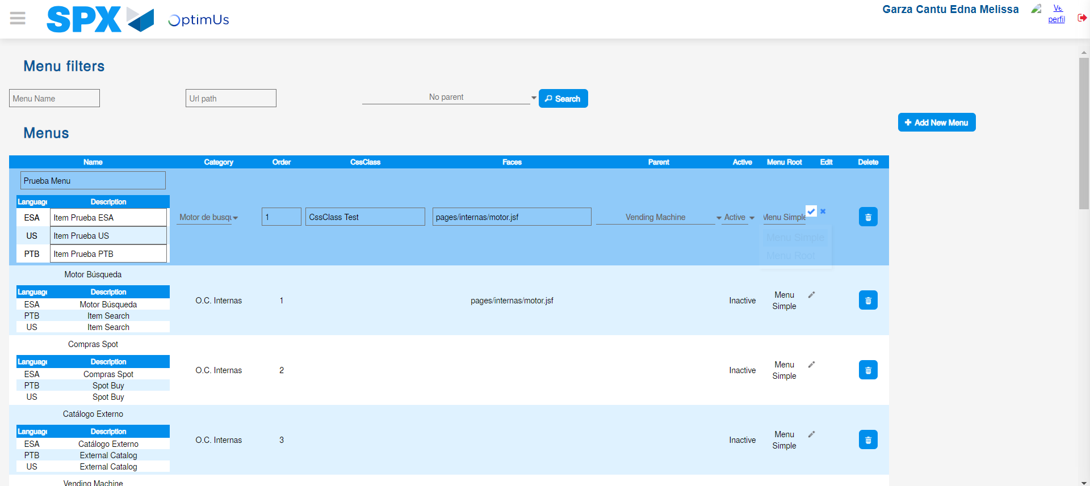Image file-name: QC_Testing-tc007_SPX_Dev5_Validacion_Boton_Edit_Administrador_Menu-may. 15 2024, 01 03 18 p. m.

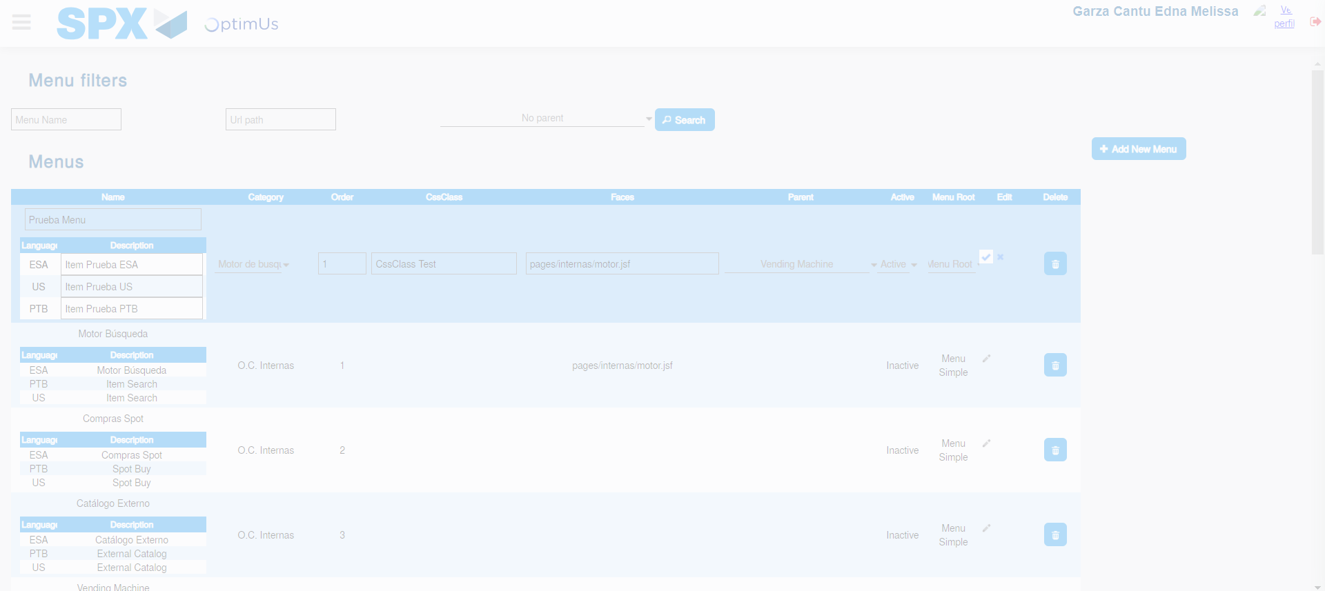Image file-name: QC_Testing-tc007_SPX_Dev5_Validacion_Boton_Edit_Administrador_Menu-may. 15 2024, 01 03 19 p. m.

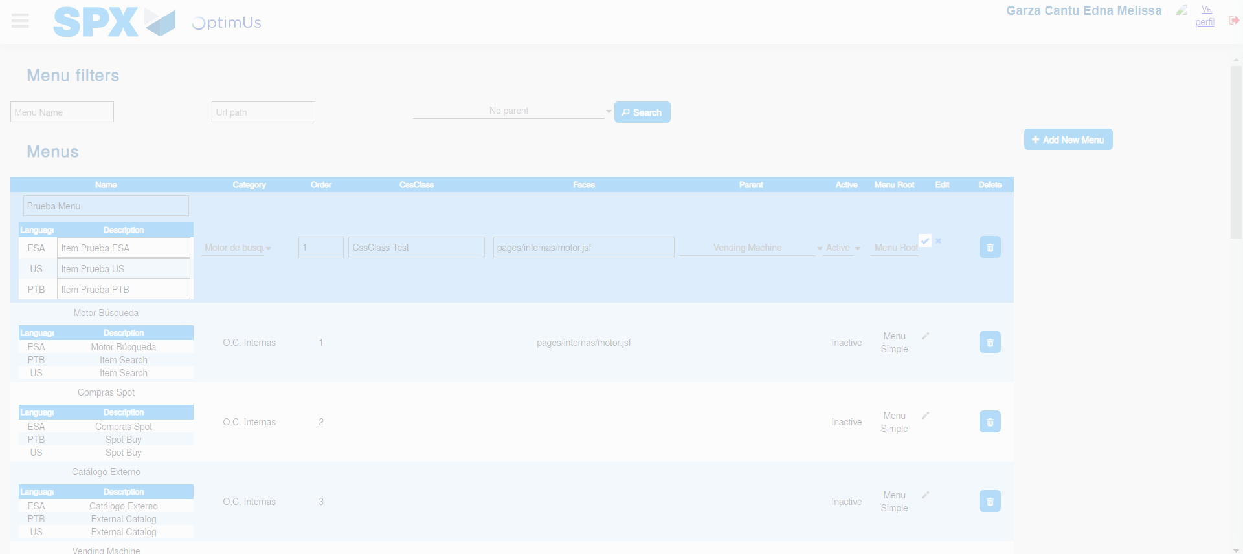Image file-name: QC_Testing-tc007_SPX_Dev5_Validacion_Boton_Edit_Administrador_Menu-may. 15 2024, 01 03 20 p. m.

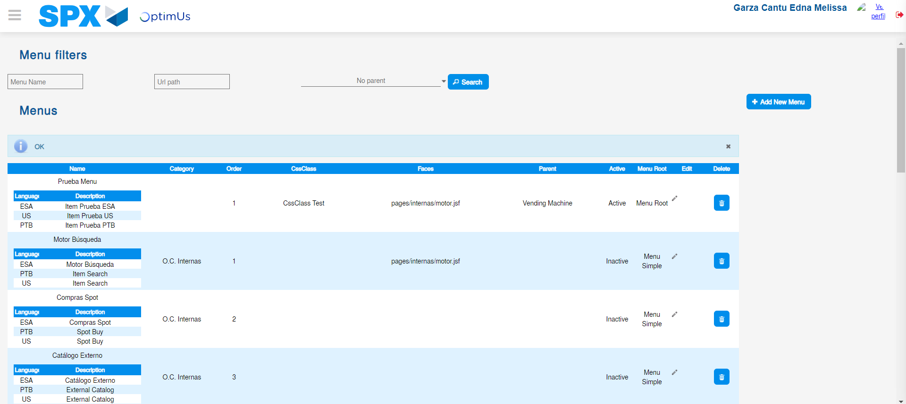Image file-name: QC_Testing-tc007_SPX_Dev5_Validacion_Boton_Edit_Administrador_Menu-may. 15 2024, 01 03 23 p. m.

